Final Project Design Phase
Computer Science - Week 11
Oct 3, 2026 - Version 0.0.4

For complete instructions and project ideas, refer to the assignment in Canvas. Specifically, review the final project requirements before you continue below. If you have not reviewed the project requirements in Canvas (you might have to go to the modules view and check the current or past week's content), you will not be able to properly complete the parts below. In addition, it may be helpful to review the information on this Drafter documentation page.

0) Project Planning and Preparation
Successful programmers spend time planning before they begin coding. After reviewing the project requirements, answer the following questions to help guide your design and development process.
- What concepts from class or previous assignments might help you complete this project? Which programming concepts (loops, conditionals, lists, classes, etc.) do you expect to use? What programming skills do you want to improve while completing this project?
I expect to use for loops, conditionals, lists, dataclasses, and many more concepts from the class. The programming skills I want to improve are my drafter skills.

- Which parts of the project do you expect to be the easiest for you? The hardest? Why?
I expect the function defining to be the easiest, and connecting the functions/implementing the drafter aspects to be the hardest.

- Even though you have not yet designed the final project, estimate which tasks will likely require the most time and effort? Which features or components should be implemented first?
The drafter implementation will take the most time/effort. I plan to first create the normal program that completes the task and then to turn it into the site.

- What distractions might interfere with your work and how will you minimize them? What resources will you need available while working? What questions, if any, do you still have about the assignment requirements?
Some distractions that might interfere with my work are the rest of my classes and the other assignments for this class. I will minimize them by managing my time properly.

1) Site Diagram
Create a mock-up of your planned website. We suggest you make the mockup on paper, although you can also use software like PowerPoint or Slides to make a mockup. There is other design software that could also be used, but we strongly encourage you to keep it simple. Do not spend more than 15-30 minutes detailing the mock-up. Your goal should be to make a very quick and dirty diagram, to show that you have some kind of idea.

We recommend drawing each page as a rectangle, and laying out the text, buttons, and other components inside. Then, use arrows to indicate links between pages. Label each page the way you will name each function, and then put labels on the arrows to indicate what the button links. Also write down any parameters that should come into the pages.

In addition to the pages and routes, write down what fields your `State` will have, both their names and types. Think clearly about what data will need to be persistent across the entire website.

Add photo(s) or screenshot(s) of your website mock-up and labeled diagram on the next page.
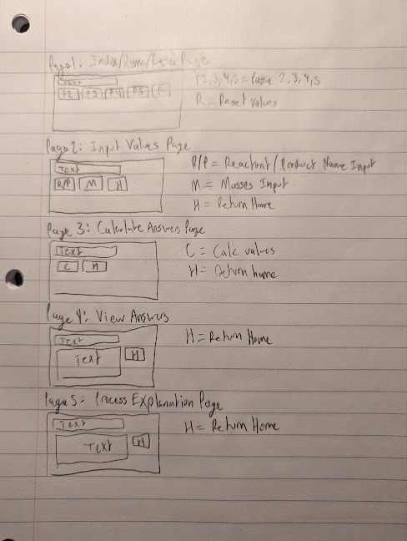
2) Implementing Requirements
This table should serve as a draft for how you will implement the requirements into your final project. You may change your ideas later on, but your final site must fulfill all the requirements.

Requirement | Implementation
Purpose/Functionality  A 1-2 sentence description of the purpose or functionality of your site | The purpose/function of my website is to take in masses of reactant, a mass of product, and a balanced chemical reaction, and produce a solution that defines the reactants as limiting or excess, determines the theoretical yield of product, and determines the percent yield of the reaction.
State Dataclass Attributes  Minimum of 4 attributes, one of which must be a list/dict of instances of your second dataclass.  Briefly describe each attribute, its type, and how it will be meaningfully modified throughout the site. | My state dataclass will look like this:  @dataclass  class State:  reactants: list[Chemical]  products: list[Chemical]  massreac1: float  massreac2: float  actualyield: float  limreac: str  excessreac: str  theoyield: float  percentyield: float
Second Dataclass  Your second dataclass, including its attributes, their types, and how they will be meaningfully modified (if they are modified) | My other dataclasses will look like this  @dataclass  class Chemical:  name: str  elements: list[Element]  physicalstate: str  coefficient: int  gramsamount: float  @dataclass  class Element:  symbol: str  molarmass: float  molecsof: int
Routes (minimum 7)  The names of your route functions | 1-5: inputs (routes)  6-10: chemistry helper funcs (not routes)  11-13: outputs (routes)  1. index: starts the page and shows basic info  2. reactantinput: asks user for reactants and transforms the input into reactant section of balanced rxn  3. productinput: asks user for products and transforms the input into product section of balanced rxn  4. reacmassinput: asks user for mass of the reactants and transforms into usable float  5. prodmassinput: asks user for mass of the product and transforms into usable float  6. masstomole: takes in a float in grams and converts to moles of same chemical using molar mass  7. moletomole: takes in a float representing moles of one chemical and converts to moles of another chemical using coefficient  8. findlimreac: takes in 2 floats representing the moles of product produced by each reactant and defines the smaller float’s corresponding reactant as the lim reac  9. findtheoyield: takes in a float representing the moles of product produced by the lim reac and converts it back to mass in grams using molar mass  10. findpercentyield: takes in 2 floats representing theo yield and actual yield, and then divides them and multiplies by 100 to find the percent yield  11. returnresults: displays to user the specified limiting reactant, theoretical yield, and percent yield.  12. reset: resets the page to base state where every field is cleared/blank  13. explainprocess: explains how the calculations were completed to user
Pages (minimum 5)  A brief description of the pages in your site | 1. Index/Home/Reset Page - blank page where user can choose to input values, calculate answers with inputted values, view answers or see explanation.  2. Input Values Page - page with buttons for inputting the masses and reacs/prods for the balanced rxn  3. Calculate Answers Page - page with button for calculating the answers with the inputs given  4. View Answers Page - page that gives answers for the defined limiting reactant, theoretical yield, and percent yield.  5. Process Explanation Page - gives explanation of how the calculations were carried out
User Input (minimum 3)  Description of user input components (TextBox, TextArea, CheckBox, or SelectBox) and their purposes  For more information on these input types, see Drafter Documentation. | The user inputs functions were described above  reactantinput: asks user for reactants and transforms the input into reactant section of balanced rxn  -TextBox  productinput: asks user for products and transforms the input into product section of balanced rxn  -TextBox  reacmassinput: asks user for mass of the reactants and transforms into usable float  -TextBox  prodmassinput: asks user for mass of the product and transforms into usable float  -TextBox
If Statements (minimum 3)  Brief description of what will be evaluated in your if statements and how they will meaningfully change the logic of the site | If statements will be widely used in the input functions to create the usable forms of the inputted data
Loop (minimum 1)  This loop must iterate over the list/dict of dataclass instances in your State attribute.  Description of this loop and why it is meaningful to the site | I will use a for loop to iterate over the lists of Chemical to produce a balanced reaction.  I will also use a for loop to iterate over the lists of Element to produce the Chemical.

LLM Conversation
If you used an LLM in any part of this work, copy and paste every part of that conversation below. Otherwise, you may be given a zero for the assignment. Obviously, these words will not all be yours, and this is the exception to the requirement at the top of this assignment that all responses be in your own words. If you did not use an LLM to assist you in this assignment, simply say so below.
No LLM

Final Submission
When you are finished, download this file as a Word Document (docx) and upload the file to the appropriate assignment on Canvas.

